Onboarding Feedback Template

Meeting date:

Collaborator’s name |  | Manager’s name
Job position: |  | Job position:

How and why conduct this interview?

Onboarding feedback is a necessary overview in order to check that the collaborator is satisfied with their arrival in the company. We recommend you to conduct this meeting approximately 1 to 2 months after the arrival of a new collaborator.
.

Overview

How do you feel today compared to your first day within our company?

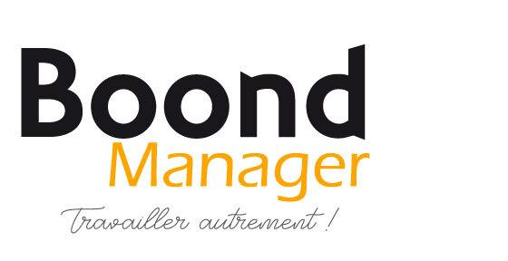
How did your first month go?

Does your experience so far coincide with the image you had in mind of the company before your arrival?

Were you surprised by a few things? If so, what were they?

Do you wish to be guided on any specific matter?

Do you have all the necessary tools to work efficiently?

What did you miss during your first month of onboarding within our company?

Do you think you had access to a sufficient amount of information? Do you see any area of improvement?

Do you have any comments concerning your work volume?

What’s your relationship with your team? And other departments?

What would rather improve your onboarding?

🤝 Working together

Are you able to easily contact your Manager when you have any questions?

What recent actions from your manager did you appreciate?

Can your manager do anything differently in order to have a better impact and to work better with you?

Any additional feedback?

